OS lab 3
Synchronization and Mutual Exclusion
++++++++++++++

Made By:
Mohamed Ramadan Mohamed
57
Problem Definition:

- Complete three function using pthread mutex to simulate a train station boarding and loading.

Code Organization:

- Program flow is organized into four stages:
1- Taking input (user , file).
2- handling input. Choosing wehther this is a special command , comment or a declaration.
3- modifying parameters if it contains variables.
4- executing commands and displaying results to user.

- Main Functions:
1- main(): the function that call all the underlying functions when needed.

2- dirtyWork(): takes one line of input and then process that line. It checks the input if it has a correct number of (“”) and then clears unnecessary spaces and then sends the command to execute().

3- execute(): the core function of the program it takes the line after it's validated and divides it into arguments array and then checks if the command is special command or a declaration command or anything else. Also it sees if the command has '&' at its end and to run it on foreground or background.

4- executeDummy(): whether the code is run in background or foreground this function is called in both cases. It takes the command and checks whether it has its path or it is in one of the paths defined in the $PATH variable and then sends the command to execv() by system call to execute it.

5- executeCD(): handling the command 'CD' mainly by using chdir() call.

6- executeHistory(): called whenever the command 'History' is called and used to display all the commands that the user made.

7- terminate(): this is responsible for handling 'exit' command and is used to close the program.

8- executeDeclaration(): this called whenever a declaration is made in format (\s+=\s+). it uses a vector-like data structure to keep the LHS and RHS. If the same LHS is entered no new entery is made and only RHS is changed.

9- handleProcessTerminated(): this function is initiated by signal() and is called whenever a child process is terminated.

10- initialize(): this function initializes multiple array and pointers that is used during the program execution.

11- error_msg(): this function is the way every function display any error happened to it. It display the corresponding message to the errors declared in error_codes.h in stderr that all the functions use to declare error.

How to run the program:

this program runs only in unix-like systems because of system calls. So in this tutorial it's assumed that it will run on a unix-like system.

1- change directory to the program folder “tinyShell” using 'CD'.
2- type 'make' this will compile the code and make an executable file.
3 –
A- interactive mode:
I. type ./tinyShell and the program will run in interactive mode.
b- batch mode:
I. type ./tinyShell lab1_test.txt this will run the pre-made test file that was put on piazza.
II. type ./tinyShell [complete file path] this will run the program in batch mode on this file.
Sample Runs:

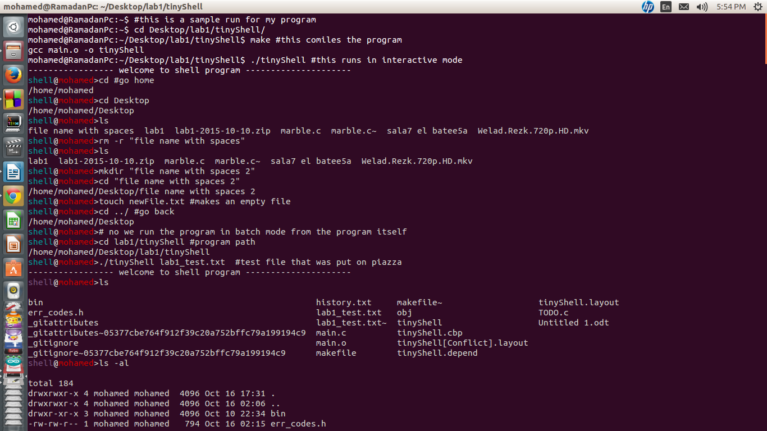
….
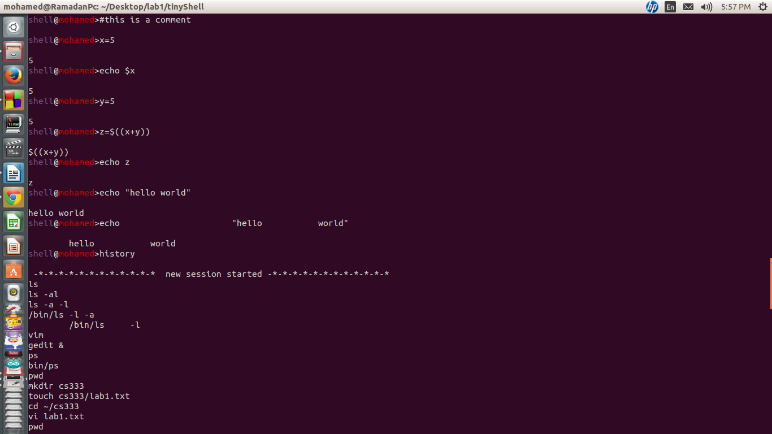
….
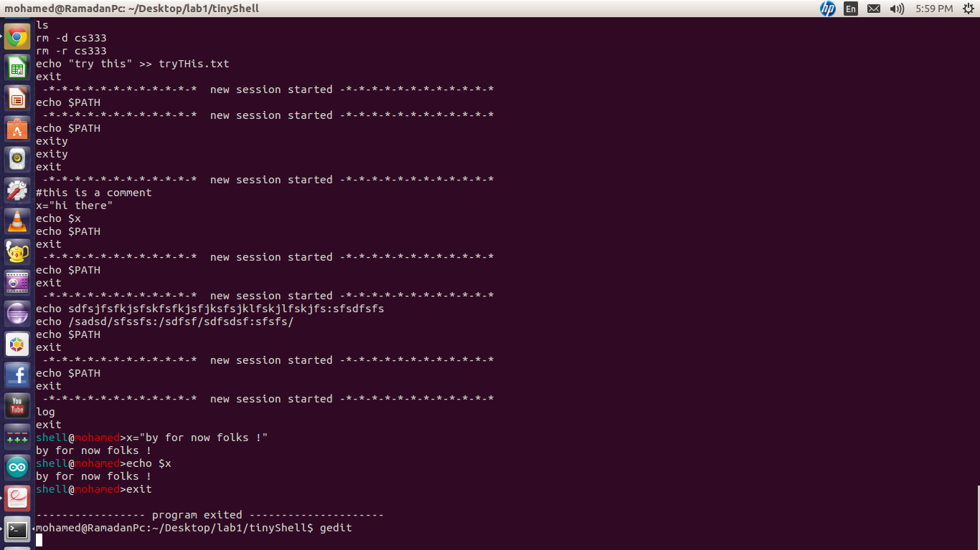
the full sample run is in file : run_case1

